Dear Members,
We are pleased to announce that effective (date of go-live), (Club Name) will be upgrading our payment platform within our website to provide you with an improved user experience and empower our Club with a modernized, optimized toolset for payment and statement administration. In conjunction with the move, we wanted to communicate highlights of the change that will be of interest to you.
Updating Payment Information (Make A Payment Tab)
1. Click on Manage Payment Methods within PayCloud
2. Click Add Bank Account
3. Enter your bank, or credit card, information as prompted.
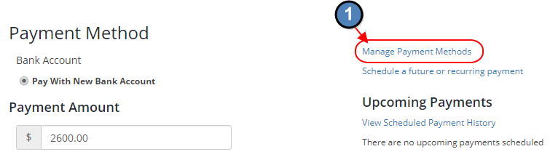
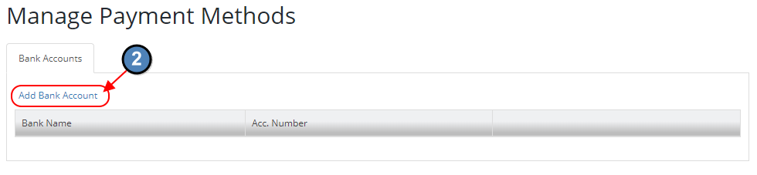
Updating Scheduled/Recurring Payments
The payment options will allow you to make one time and scheduled payments, either from your desktop or from the convenience of your mobile device. All stored payment methods are tokenized and encrypted for maximum security.
1. Make a one-time payment
2. Save a new payment method to your file
3. Schedule a future or recurring payment.
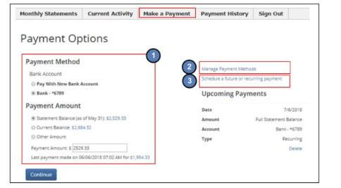
We hope you enjoy the new online payment and statement experience. If you have any questions, please feel free to contact the accounting department.

