Hello (Member name),
We are pleased to announce that effective (date of go-live), (Club Name) will be upgrading our payment platform within our website to provide you with an improved user experience and empower our Club with a modernized, optimized toolset for payment and statement administration. In conjunction with the move, we wanted to communicate highlights of the change that will be of interest to you.
Important Auto Payment Message
Any Member that is currently set up to have the Club draft their Bank Account or Credit Card on the 20th of the Month will need to Re-Enter their Bank Account/ Credit Card AND Enroll themselves in Autopay. Please review the Autopay Enrollment Section of the document for exact instructions on how to do so.
Autopay Enrollment
- Click on Manage Payment Methods within Paycloud
- Click Add Bank Account or Add Credit Card
- Enter your bank, or credit card, information as prompted.
- Navigate to the Auto Draft Account Tab.
- Select either the Bank Account or Credit Card you have added on file and click Set as Auto Draft Account. This will guarantee your Bank Account/ Credit Card will be drafted on the 20th of each month.
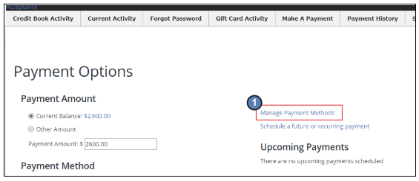
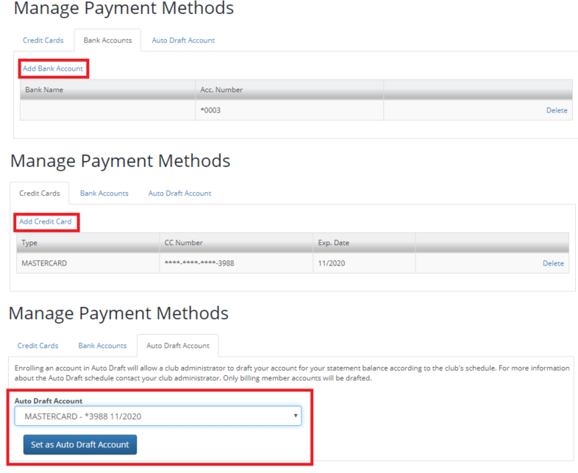
Additional Implications/ Functionality?
- Even if you are not enrolled in Autopay, you will still need to re-enter any saved payment information.
- In addition to the autopayment feature on the 20th of the month, you also have the ability to schedule your own recurring payments on whichever day of the month you choose.
Updating Payment Information
- Click on Manage Payment Methods within Paycloud
- Click Add Bank Account or Add Credit Card
- Enter your bank, or credit card, information as prompted.
- For a full guide of adding payments, please review our Paycloud Guide.
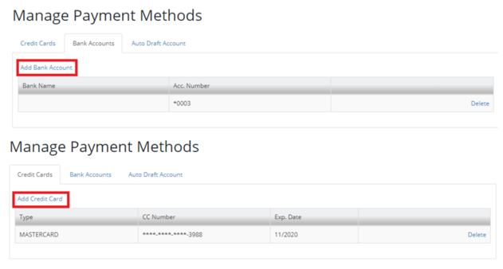
Updating Scheduled/Recurring Payments
The payment options will allow you to make one time and scheduled payments, either from your desktop or from the convenience of your mobile device. All stored payment methods are tokenized and encrypted for maximum security.
- Make a one-time payment
- Save a new payment method to your file (Credit Card or Bank Account)
- Schedule a future or recurring payment.
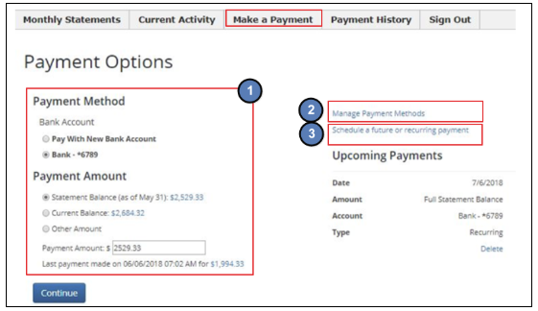
We hope you enjoy the new online payment and statement experience. If you have any questions, please feel free to contact the club!

